Predicting Product Development Time and Cost Using Machine Learning
Vaishnavi Dutt, Varnika Singh, Vandana Singh
Department of Computer Science and Engineering, ABES Engineering College, Ghaziabad
Guide: Ms. Divya Maheshwari
Abstract—Nobody sets out to misjudge a project's timeline or budget, yet it happens constantly, and by the time the miscalculation is obvious, the damage, a missed deadline, an overspent budget, sometimes both, is already done. The usual ways of guessing at this in advance, expert judgment or a parametric formula like COCOMO, run on assumptions that stop holding up the moment a project's scope, team, or domain shifts, which leaves teams working across more than one kind of project without a tool that actually fits. EstimateX is our attempt at something different: a machine learning system trained on real historical project data rather than a fixed equation. We train and compare four models, Linear Regression, Random Forest, XGBoost, and Support Vector Regression, on established effort estimation datasets, and check their output against standard error metrics. Just as important to us as raw accuracy is being able to say why a prediction came out the way it did, so EstimateX also runs feature importance analysis to surface which project attributes actually drove a given number. What we are aiming for is not a perfect oracle. It is a tool practical enough to use, flexible enough to work across domains, and honest enough about its own reasoning to be trusted a bit more than a rigid formula or a typical black-box calculator.
Index Terms—Machine Learning, Cost Estimation, Effort Estimation, Software Project Management, Regression, Predictive Modeling

I. INTRODUCTION
How long will this take, and what will it cost? Nearly every product team asks this question early on, and the answer shapes almost everything that follows. Get it wrong, and the consequences rarely show up right away. They show up months later, as a deadline that quietly slips, a budget that runs dry, or a project that gets shelved before it is finished. This is not a new problem. Estimation techniques have been studied for decades, yet both under- and over-estimation are still common in practice, and the gap between what was predicted and what actually happened is often large enough to decide whether a project gets approved in the first place.
The approach most students learn first is the Constructive Cost Model, or COCOMO, which works out effort and duration from a handful of size and complexity numbers plugged into a fixed formula. That is fine as long as the project looks like the ones COCOMO was calibrated on. The moment the team, the tooling, or the type of project changes, the formula stops adapting. Expert judgment, the other common route, has the opposite problem. It depends entirely on how experienced the person doing the estimating happens to be, and that experience rarely transfers cleanly from one team or domain to another.
Machine learning approaches the problem differently. Rather than assuming one fixed relationship between project attributes and effort, it learns that relationship from historical data and can be retrained as more data comes in. In practice this makes it far more adaptable across project types, which matters for teams that do not stick to a single, narrow category of product.
There is a second problem that gets less attention: a lot of existing estimation tools either work for one domain only, or behave like a black box, handing back a number with no explanation of where it came from. EstimateX, the system proposed in this paper, is built to close both gaps. Project domain is treated as just another input feature instead of needing a separate model for every domain, and feature importance analysis is used so a prediction can actually be explained instead of simply taken on faith.
II. RELATED WORK
Prior work in this space is fairly consistent on one point: machine learning beats formula-based estimation almost every time it gets tested against it.
Take the evidence from outside software first. A 2025 review pulled together 39 peer-reviewed studies on AI-driven cost estimation spanning construction, healthcare, manufacturing, and real estate, and the numbers came out about how you would expect: machine learning models around 75-80% accurate, deep learning around 85-90%, hybrid approaches somewhere in the 80-90% range too, with XGBoost doing particularly well in construction work specifically. The catch the authors were honest about is that deep learning's edge does not come free. It costs more data, and a fair amount of the interpretability that makes a model actually useful to a non-expert [1].
Algorithm choice is not the only lever, either. A late-2024 paper working with the COCOMO-NASA dataset tested three different feature selection methods before training its models, and found that Principal Component Analysis made the single biggest difference to accuracy, in some runs a bigger jump than switching the algorithm itself would have given [2].
Three algorithms, one dataset, one head-to-head test, that was roughly the setup of a 2023 study comparing Random Forest, Gradient Boosting, and Support Vector Regression on the same effort estimation problem. Random Forest won out on consistency [3].
Further back, in 2019, a regression-based ML approach was tested directly against COCOMO on the same historical project data for predicting effort, duration, and cost, and it came out ahead [4].
The oldest study in this set, from 2007, threw several methods at the problem at once: back-propagation neural networks, regression trees, radial basis function networks, and support vector regression paired with PCA, tested across three datasets pulled from NASA, USC, and a Turkish software company. Nothing won everywhere. Regression trees came out on top for the NASA and Turkish data, RBF networks with PCA won on the USC set, but every single approach beat COCOMO regardless of which dataset it was run on [5].
TABLE I. SUMMARY OF REVIEWED STUDIES
Ref. | Year / Technique | Key Finding
[1] | 2025, ML/DL review | ML: 75–80%; DL: 85–90%, less interpretable
[2] | 2024, feature selection | PCA gave the largest accuracy gain
[3] | 2023, RF/GB/SVR | Random Forest most consistent
[4] | 2019, regression ML | ML beat COCOMO on same data
[5] | 2007, NN/RT/RBF/SVR | No single algorithm won every set
Two things stand out once all of this is lined up together. Machine learning's edge over formula-based estimation is not limited to software, it shows up in construction and healthcare cost estimation too, which backs treating this as one cross-domain, data-driven problem instead of reinventing a formula for every field. And explainability keeps getting skipped. Almost nobody in this set of studies bothers to say why their model predicted what it did, and that gap only gets more important as these tools move from academic papers into something people actually rely on for real decisions.
III. PROPOSED METHODOLOGY
A. Dataset
EstimateX is trained on the COCOMO-NASA and Desharnais datasets, both hosted on the PROMISE Software Engineering Repository [6], a public archive of software project data that gets used widely in effort estimation research and, importantly, is free to access. COCOMO-NASA holds historical project records with effort measured in person-months alongside size and complexity attributes. Desharnais is a separate set of real project records built around team experience and project size instead. Working with two independently collected datasets, rather than just one, gives a better sense of how well the models generalize beyond a single source.
TABLE II. DATASET SUMMARY
Dataset | Key Attributes | Source
COCOMO-NASA | Size, effort (p-months), complexity | PROMISE Repo.
Desharnais | Team experience, size, effort | PROMISE Repo.
B. Data Preprocessing
Before any of that, the raw project records need cleaning up. Missing values get handled first. Then numerical features are normalized, because otherwise something like team size sitting next to lines of code would let whichever number is bigger quietly dominate training. Project type and the other categorical attributes get turned into numbers too, since that is the only way to hand them to the models directly.
C. Model Training
Four algorithms go head to head on the same preprocessed data. Linear Regression is the simple baseline here, nothing fancy. Random Forest and XGBoost were pulled in because both performed well in the studies discussed earlier, and Support Vector Regression fills out the fourth slot. Training uses k-fold cross-validation across the board, mainly to keep overfitting in check given how small the dataset is, and every model sees the same train-test split so the comparison actually means something.
D. Evaluation Metrics
Two things are checked here. First, Mean Absolute Error and Root Mean Squared Error, which say roughly how far off a prediction tends to be. Second, Mean Magnitude of Relative Error and PRED(25), a pair that shows up specifically in effort estimation papers because they measure closeness in relative terms rather than raw numbers.
E. Explainability
Once a model is trained, feature importance scores get pulled out of the tree-based ones to see what actually pushed the prediction one way or another, team size, complexity, domain, whatever it turns out to be. Without this step EstimateX would just be another number-generator, and the whole point was to avoid that.
F. Deployment (Planned)
Training and evaluation come first, deployment after. The current plan is a lightweight web app, Flask or Streamlit most likely, where a user types in a project's details and gets back an estimate along with whatever factors mattered most for that particular prediction.
IV. SYSTEM ARCHITECTURE
Fig. 1 sketches the path from raw historical data to a final number. Preprocessing and feature engineering happen first, the four models get trained and compared next, and whichever one performs best has its predictions paired with a feature importance breakdown before anything reaches the user. That last step is what turns a plain estimate into one with a reason attached.
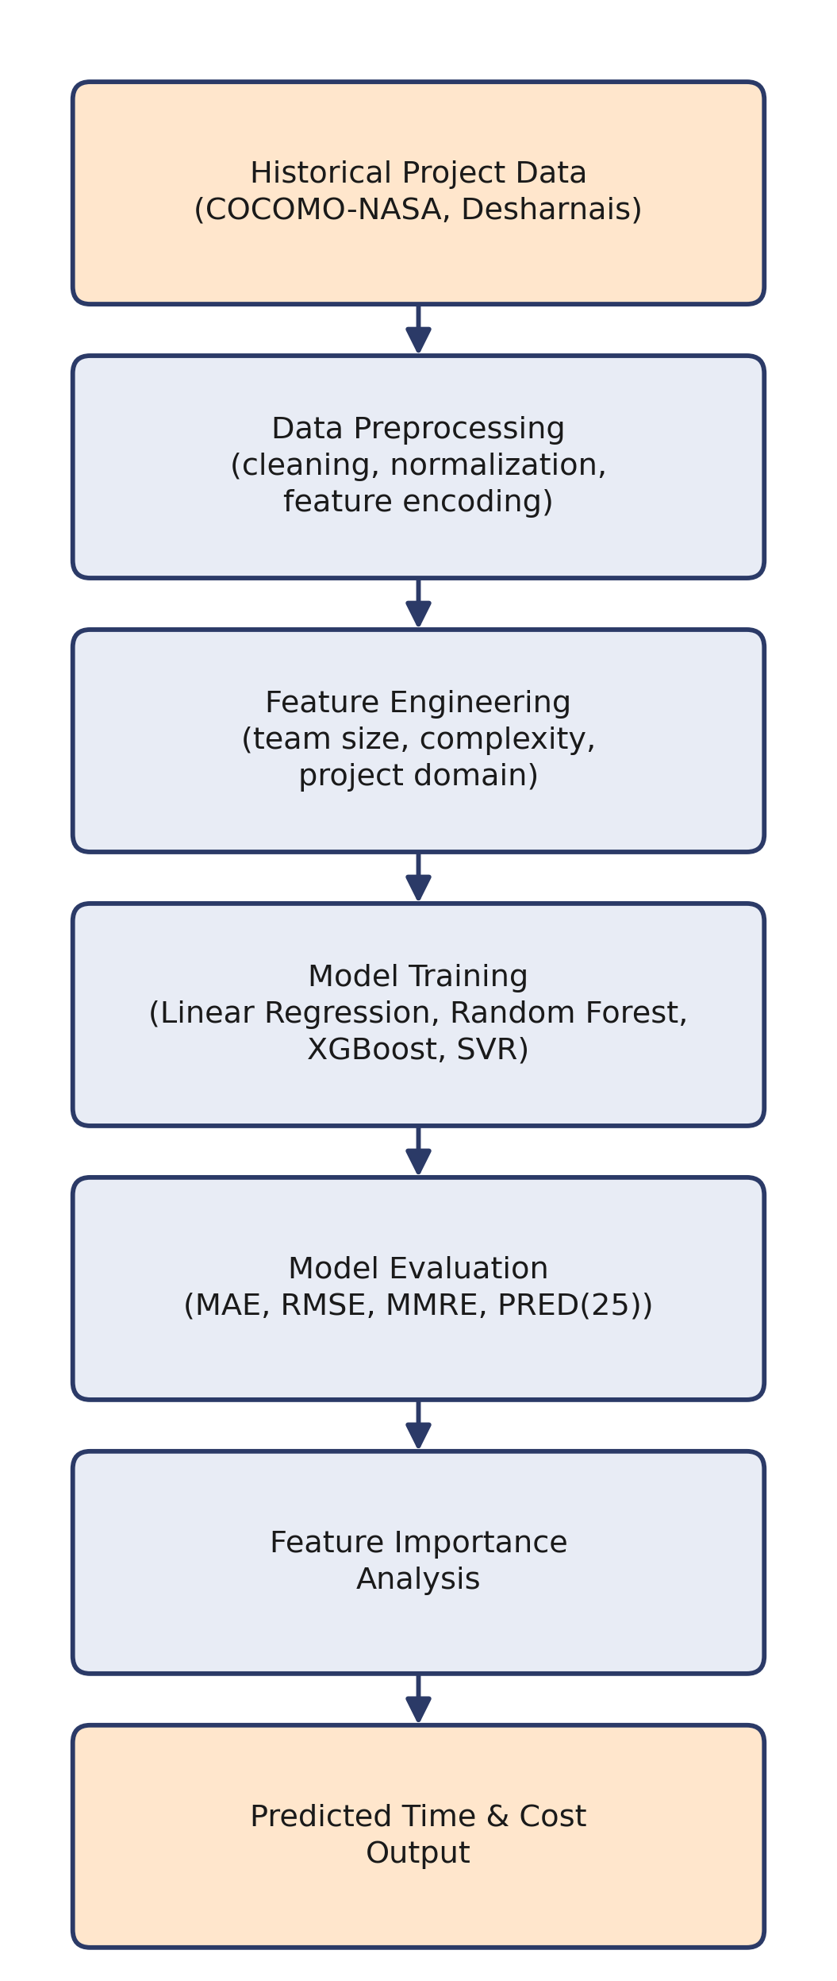
Fig. 1. Proposed system workflow for EstimateX.
V. EXPECTED OUTCOMES
EstimateX has not been trained yet, we are still at the data-preparation stage, so what follows is a forecast rather than a result. Based on how the reviewed studies played out, an ensemble method is the likeliest candidate to come out on top, and whichever model wins should beat a COCOMO-style baseline by a real margin, not just a rounding error. Alongside that, we expect a ranked breakdown of which project attributes are actually driving the estimate, since a planner gets more use out of that than a single unexplained number. And further down the line, once there is a working interface, someone should be able to type in a few project details and get an estimate back without touching any code or needing to understand what is happening underneath.
VI. LIMITATIONS AND CHALLENGES
Free and well established does not mean perfect. COCOMO-NASA and Desharnais together are still under two hundred project records combined, which limits how complex a model can be trained before it starts memorizing rather than learning, and neither one was collected with today's software practices in mind, cloud-native pipelines, agile sprints, products that span several domains at once. So predictions from EstimateX are best read as estimates grounded in historical patterns, not guarantees, and that caveat gets stronger the further a project sits from what the training data actually looks like.
A harder problem sits underneath that one. Project domain, complexity, and team structure never reduce cleanly to a handful of numbers without losing something. Two projects can look identical on every feature the model sees and still take very different amounts of effort in practice, for reasons that simply are not captured. Feature importance helps with interpreting a prediction, but it does not erase that gap. Fixing either limitation really comes down to the same thing: more data, more recent and more varied across domains, which is exactly what the future work below is aimed at.
VII. CONCLUSION AND FUTURE SCOPE
What this paper lays out is EstimateX: a machine learning system meant to predict product development time and cost across multiple domains, and to explain its own predictions rather than hide behind a single number. The methodology is not invented from scratch, it builds on what prior work in this area has already found, and it runs on data that stays freely accessible rather than locked behind a paywall. What remains is the actual work, training the models described here, pulling in more domains beyond the two datasets used so far, and getting the planned web deployment far enough along that real users can test it instead of just a held-out slice of data.
REFERENCES
[1] M. M. I. Shamim, A. B. A. Hamid, T. E. Nyamasvisva, and N. S. B. Rafi, “Advancement of Artificial Intelligence in Cost Estimation for Project Management Success: A Systematic Review of Machine Learning, Deep Learning, Regression, and Hybrid Models,” Modelling, vol. 6, no. 2, Art. 35, 2025, doi: 10.3390/modelling6020035.
[2] F. Mansoor, M. A. Alim, M. T. Jilani, M. M. Alam, and M. M. Su'ud, “Enhancing Software Cost Estimation Using Feature Selection and Machine Learning Techniques,” Computers, Materials & Continua, vol. 81, no. 3, pp. 4603–4624, Dec. 2024, doi: 10.32604/cmc.2024.057979.
[3] Meharunnisa, M. Saqlain, M. Abid, M. Awais, and Ž. Stević, “Analysis of Software Effort Estimation by Machine Learning Techniques,” Ingénierie des Systèmes d'Information (ISI), vol. 28, no. 6, pp. 1445–1457, 2023, doi: 10.18280/isi.280602.
[4] “Predicting Effort, Duration and Cost in Software Development Using Machine Learning Technique,” Journal of Advanced Research in Dynamical and Control Systems (JARDCS), 2019, available at jardcs.org/abstract.php?id=665.
[5] A. L. I. Oliveira et al., “Software Effort Estimation Using Machine Learning Methods,” presented at the 22nd International Symposium on Computer and Information Sciences (ISCIS), 2007.
[6] PROMISE Software Engineering Repository, University of Ottawa, promise.site.uottawa.ca/SERepository.

